**Aim:** Create a simple cloud software application for Property Buying & Rental process (In Chennai city) using any Cloud Service Provider to demonstrate SaaS include the necessary fields such as Buy, Rent, commercial, Rental Agreement , Rental Agreement, Area, place, Range, property value etc

**Step 1:** create an application and add ‘area’, ‘property details’, ‘area details’, ‘payment details’

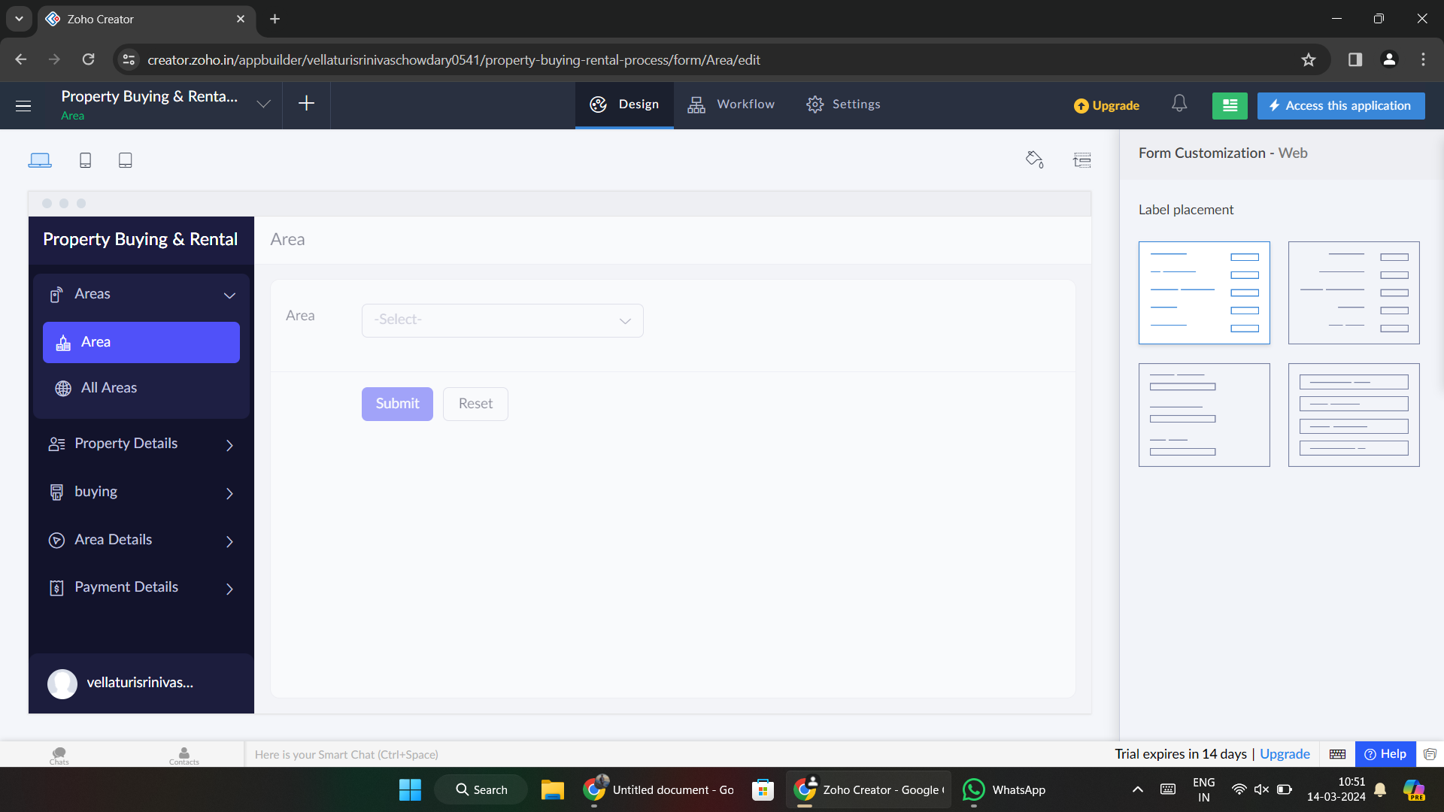

**Step 2: add required details on each file**

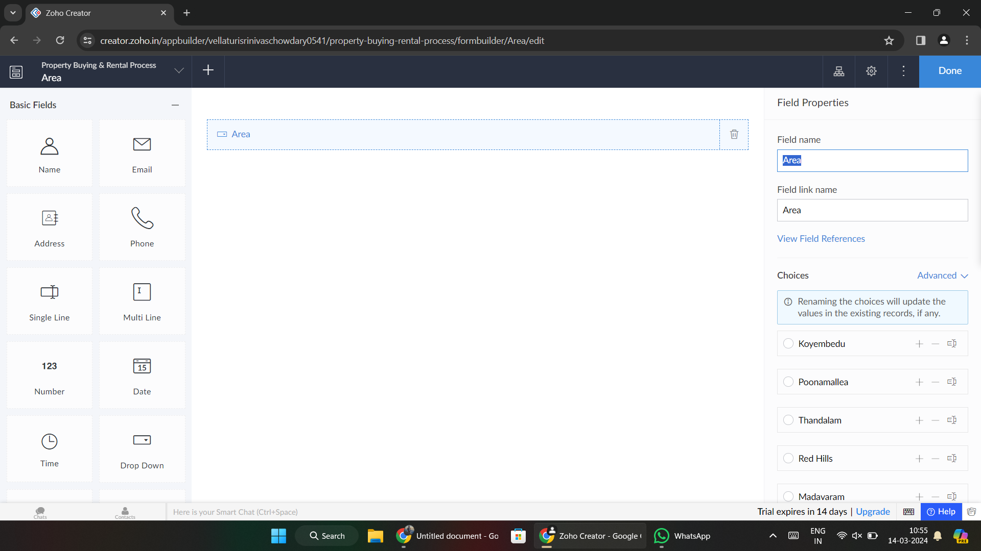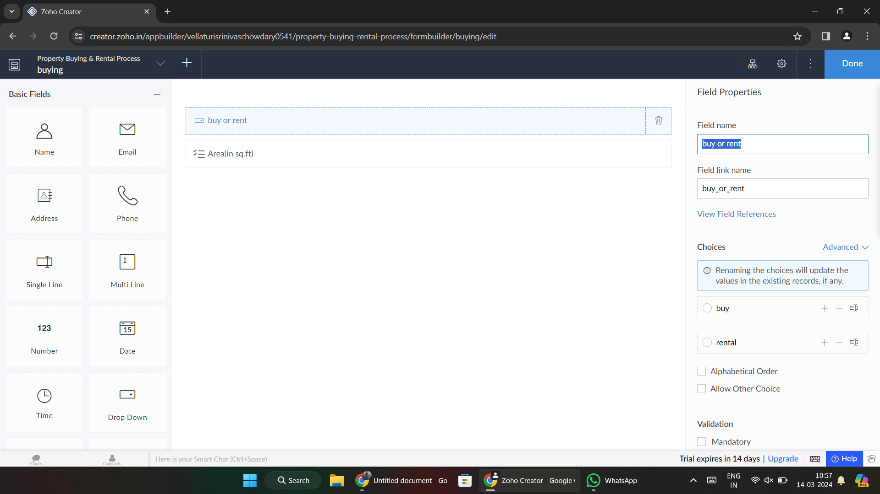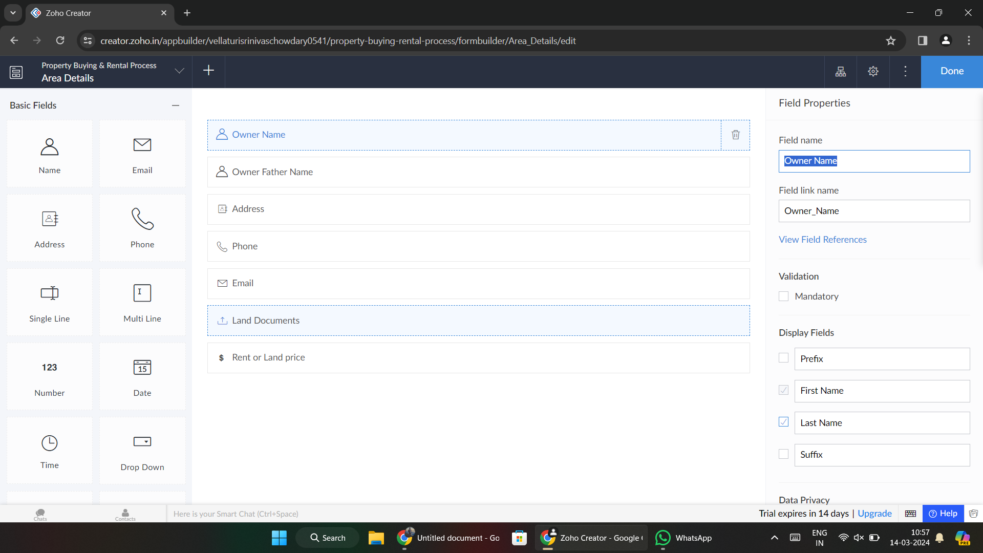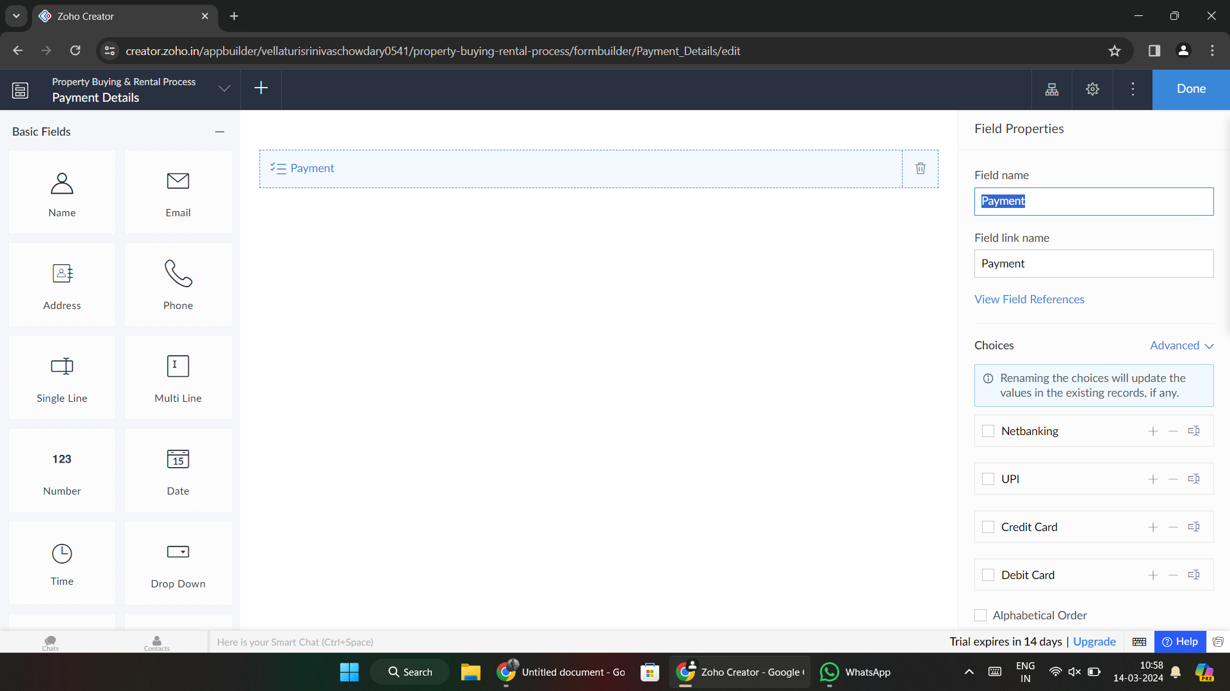

**Step 3:** Click on ‘access this application’ and the application is ready.

